**Kaif Ikhlaq**

**SU92 BSAIM S24 – 036**

**Task : 5**

* **1 :**

The code implements a depth-first search (DFS) to find a goal node in a graph, starting from a given node. It recursively explores neighbors and prints "Goal found!" if the goal is reached, while also tracking and displaying visited nodes.

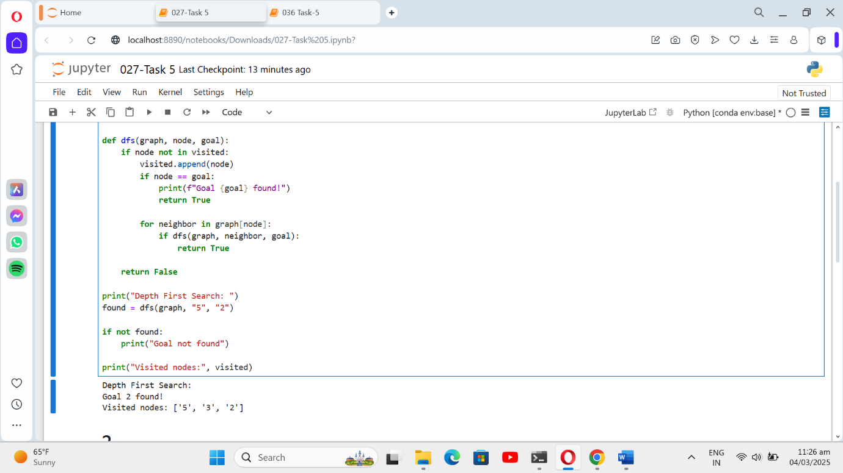

* **2 :**

The code defines a binary tree and performs recursive traversals: preorder, in order, and post order. Each traversal prints the node values in the respective order: root-left-right, left-root-right, and left-right-root.

